ARMA time and frequency domain simulation

ECE3093 Assignment 2 Part C, Written by Kun Zhang (22701478)

# Q1. Investigation of WN and BM process

## (ii) Explain the behaviours you might expect of the three ARMA process

ARMA process $X_{t}=Z_{t}$ is expected to behave exactly the same as a white noise sequence. The autoregressive function is $ϕ=1$, indicating the existence of causal and stationary solutions.

ARMA process $X_{t}=Z_{t}+X_{t-1}$ essentially is a cumulative sum of the white noise, which means it is Gaussian. The zero of the autoregressive function is $z=1$, indicating the existence of causal solutions and the absence of stationary solutions.

ARMA process $X_{t}=Z_{t}+0.9X_{t-1}$ has a scaling factor 0.9 of the white noise. The zero of the autoregressive function is $z=1.11>1$, indicating the existence of causal and stationary solutions.

## (iv) Outputs of random walk (n)

The autoregressive process has been changed to $X_{t}=Z_{t}+0.9X_{t-1}$

(a) n=100

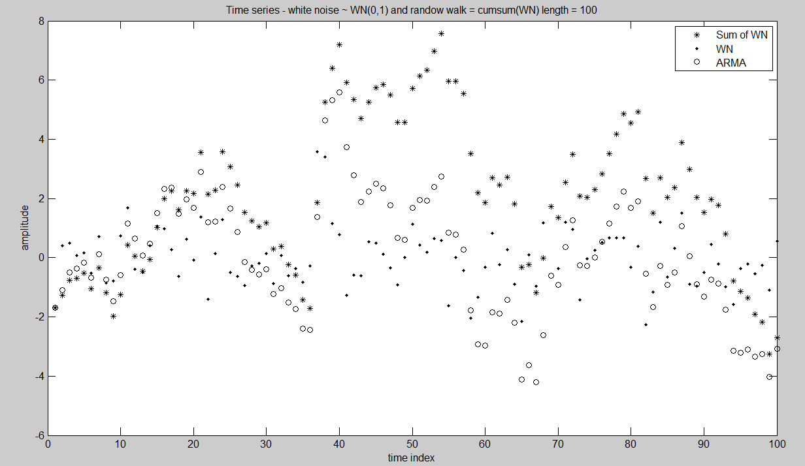

(a) n=1000

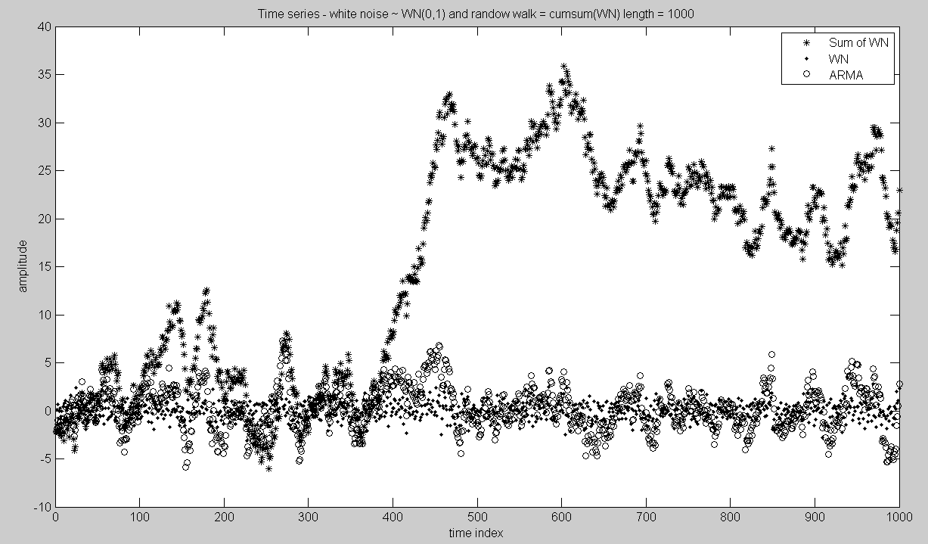

## (v) Comment on these two plots

**(1)**

${\{Z}_{t}\} \sim WN(0,σ^{2})$ is theoretically a stationary process because the random variables in the sequence have identical means, E[$Z_{t}$]= $μ=0$ and the same covariance $cov\left(Z_{t},Z_{t+h}\right)=cov\left(Z_{0},Z_{h}\right)$ with all h. This coincides with the conclusion drawn in Q1(ii)

**(2)**

A random walk would be a Gaussian process and stationary process. A random walk is a sum of white noises. As a linear process, the random walk would be expected to have Gaussian distribution. As mentioned in Q1(ii), the random walk given by $X_{t}=Z_{t}+0.9X_{t-1}$ is also expected to be stationary

**(3)**

Assuming that the random walk $Z_{t}$ are iid (independent and identically distributed)

The expectance of the sum of white noises is $E\left[Z_{t}\right]=0$

Because of the independency of ${ Z}_{t}$, the covariance at any point is zero. The variance of $Z_{t}$ is the sum, $var\left(Z_{t}\right)=tσ^{2}$

Therefore

$$\left\{Z_{t}\right\}\sim IID\left(0,tσ^{2}\right)$$

**(4)**

The white noise distributions from the plots show that the random variables oscillate around x-axis, which means their expectation is approximately zero. The dots are distributed in a random pattern, which means that the autocorrelation are not subjected to time. Thus, the WN is stationary.

The sum of WN plot exhibits a fluctuating trend which reveals that the covariance is not the same at every point.

# Q2. Investigation of an ARMA (2, 0) process

## (A)

The ARMA(2,0) process is:

$$X_{t}-aX_{t-1}-0.5bX_{t-2}=Z_{t}$$

The spectral density of white noise is:

$$f_{z}\left(λ\right)=σ^{2}/2π$$

The spectral density of X is given by

$$f_{x}\left(λ\right)=\frac{σ^{2}}{2π}{\left|\frac{θ\left(e^{-iλ}\right)}{ϕ\left(e^{-iλ}\right)}\right|}^{2}$$

The moving average polynomial,

$$θ\left(e^{-iλ}\right)=1$$

The autoregressive polynomial,

$$ϕ\left(e^{-iλ}\right)=1-ae^{-iλ}-0.5be^{-2iλ}$$

Substituting back to the spectral density function, we have

$$f_{x}\left(λ\right)=\frac{σ^{2}}{2π}{\left|\frac{1}{1-ae^{-iλ}-0.5be^{-2iλ}}\right|}^{2}$$

$$f_{x}\left(λ\right)=\frac{σ^{2}}{2π}{\left|\frac{1}{1-\operatorname{acos}\left(-λ\right)-aisin\left(-λ\right)-0.5b\cos\left(-2λ\right)-0.5bi\sin\left(-2λ\right)}\right|}^{2}$$

$$f_{x}\left(λ\right)=\frac{σ^{2}}{2π}{\left|\frac{1}{1-\operatorname{acos}\left(-λ\right)-aisin\left(-λ\right)-0.5b\cos\left(-2λ\right)-0.5bi\sin\left(-2λ\right)}\right|}^{2}$$

Let

$$M=1-\operatorname{acos}\left(-λ\right)-aisin\left(-λ\right)-0.5b\cos\left(-2λ\right)-0.5bi\sin\left(-2λ\right)$$

Therefore the real part and imaginary part is

$$R\left(M\right)=1-\operatorname{acos}\left(λ\right)-0.5b\cos\left(2λ\right)$$

$$Q\left(M\right)=asin\left(λ\right)+0.5b\sin\left(2λ\right)$$

$${\left|R\left(M\right)\right|}^{2}=1+a^{2}\cos^{2}λ+0.25b^{2}\cos^{2}2λ-2acosλ-cos2λ+abcosλ+cos2λ$$

$$\left|Q\left(M\right)\right|=a^{2}\sin^{2}λ+0.25b^{2}\sin^{2}2λ+absinλsin2λ$$

Given that:

$\sin^{2}{(x)}+\cos^{2}{(x)}=1$

$$\cos\left(x\right)\cos\left(y\right)+\sin\left(x\right)\sin\left(y\right)=cos⁡(x-y)$$

We have

$${\left|M\right|}^{2}={\left|R\left(M\right)\right|}^{2}+{\left|Q\left(M\right)\right|}^{2}=1+a^{2}+b^{2}/4+abcosλ-2acosλ-bcos2λ$$

Substituting back

$$f_{x}\left(λ\right)=\frac{σ^{2}}{2π}\left(\frac{1}{{\left|M\right|}^{2}}\right)=\frac{σ^{2}}{2π}(\frac{1}{1+a^{2}+b^{2}/4-a\left(2-b\right)cosλ-bcos2λ})$$

## (B)

The ID-indexed a=0.4380 and b=0.5336

The ARMA(2,0) process now becomes

$$X_{t}-0.438X_{t-1}-0.2668X_{t-2}=Z_{t}$$

The autoregressive polynomial is

$$ϕ\left(z\right)=1-0.438z-0.2668z^{2}$$

The roots for $ϕ\left(z\right)=0$ are

$$Z_{1}=-2.9237$$

$$Z_{2}=1.2820$$

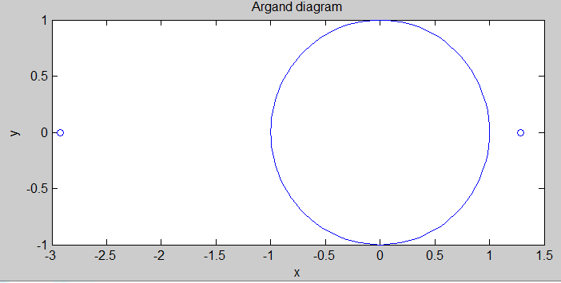

As can be seen from the diagram, both roots (indicated by small circles) are outside the unit circle. This reveals the fact that the ARMA(2,0) process is stationary and causal.

## (D)

**(1) Plot of a white noise sequence and ARMA**

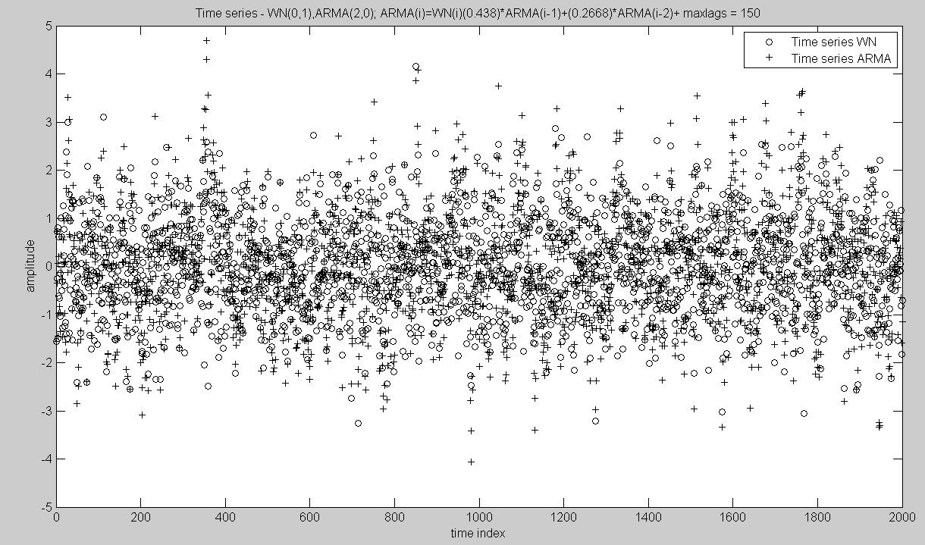

**(2) Plot of theoretical autocovariance function TACF and the sample covariance function SACF**

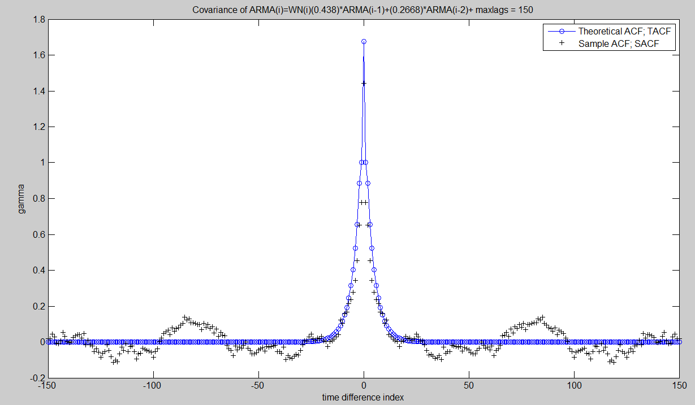

**(3) Plots of DFT of ACF, PTACF and TSDAR**

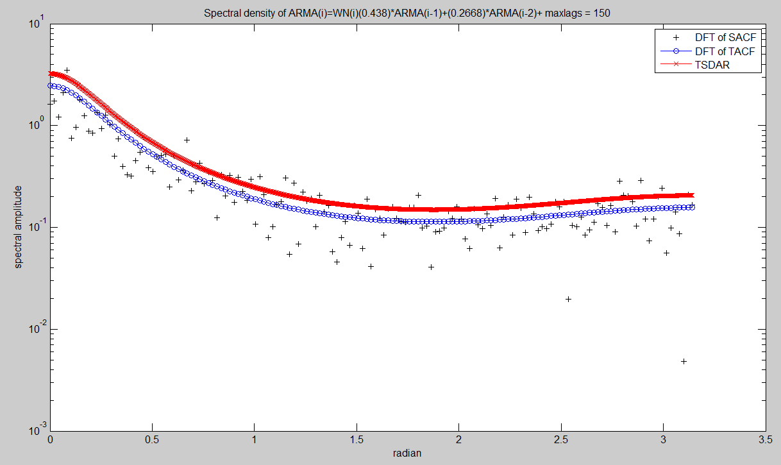

**(4) Periodogram (DFT of ARMA) and plot of TSDAR**

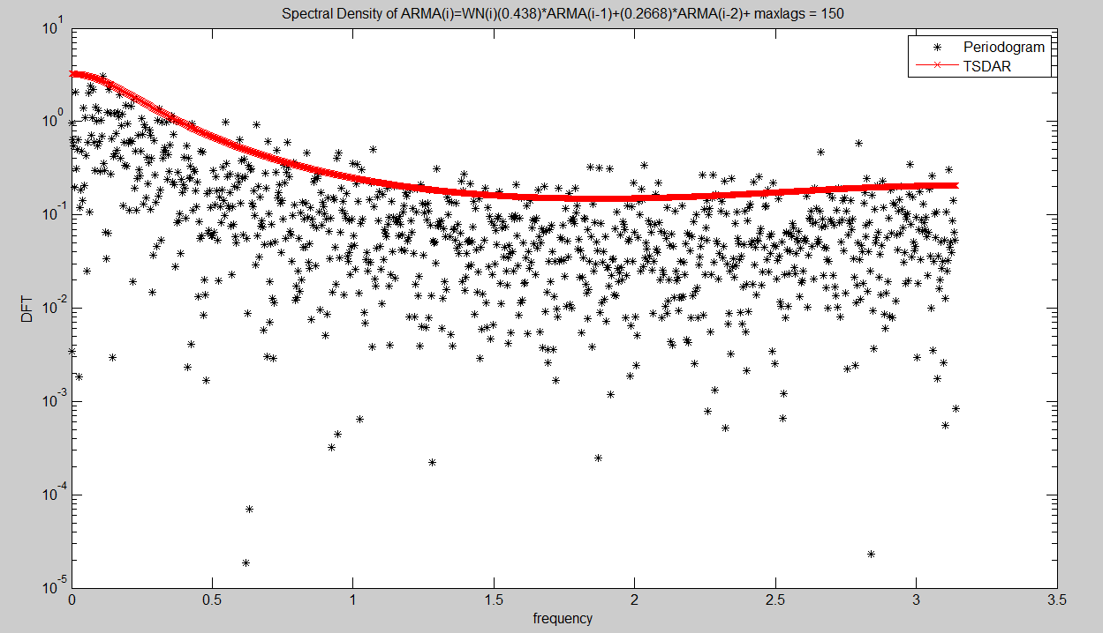

## (E) Flowchart

The flowchart shows the interconnections between X{t}, **λ{t} and f{ λ }**

**X{t}**

Sampled Observations

Sampled AFC

DFT

Periodogram

**λ{t}**

**f{ λ }**

**f{ λ }**

## (F) Discussion of the behaviour of the plots

**(i)**

Yes. Theoretically speaking, the autocovariance function $γ(h)$ should be zero everywhere except for h=0, which is evident in the TACF plot. The SACF plot, on the other hand, oscillates around zero when h takes non-zero values. The difference clearly shows that finite samples are used to generate the SACF.

**(ii)**

Unlike the plot of DFT of ACF, the plot of ACF using periodogram appears more scattered. The trend of the periodogram ACF follows that of theoretical ACF in that they both decay monotonically with similar pattern. In addition, most values of periodogram ACF are smaller than those of theoretical AFC

# Appendix

## MATLAB Code for Q1

function PartC_randomwalk(n)

%ECE3093 Assignment 2 2013

% This m-file generates a plot of a random walk overlaying discrete white noise.

% The random walk is the cumulative sum of the discrete white noise

% It can be implemented, equivalently, as:

% generate the discrete time axis

XN=ones(n,1);

XN=cumsum(XN);

% generate a white noise vector

WN=randn(n,1); %WN(0,1)

%

% Calculate randonwalk as the sum of white noise

RW=cumsum(WN); %A random walk is discrete Brownian motion

%

% Calculate the same randomwalk as an ARMA process

AR(1)=WN(1);

for i=2:n

AR(i)=WN(i)+AR(i-1);

end

newplot

plot(XN,RW,'k*')

hold on

plot(XN,WN,'k.')

hold on

plot(XN,AR,'ko')

legend('Sum of WN','WN','ARMA');

t=sprintf('Plot of white noise WN(0,1)');

disp(t)

title(['Time series - white noise ~ WN(0,1) and ',...

'randow walk = cumsum(WN) length = ', num2str(n)])

xlabel('time index')

ylabel('amplitude')

hold off

t=sprintf('Plot of random walk of length = %4d',n);

disp(t)

pause

return

## MATLAB Code for Q2 (C)

function myDFTspectra13()

%ECE3093 Assignment 2 Part C 2013

%This part C of Assignment 2 2013 aims to illustrate the

%transformation theory of a stationary time series.

%for a ARMA(2,0) process

%Written by Kun Zhang

%% 1. Edit Parameters

varZ=1;

%Use your Student ID derived a and b.

a=0.4380;

b=0.5336;

n=2000;

maxlags=150;

%

% Calculate a white noise sample; WN(0,varZ) hence sd = varZ^(1/2)

XN=ones(n,1);

XN=cumsum(XN);

WN=(varZ^(1/2))*randn(n,1); %WN(0,1) for ARMA(2,0) model.

%Model a particular ARMA model

%An general ARMA(2,0) model.

ARMA(1)=WN(1);

ARMA(2)=WN(2);

for i=3:n

ARMA(i)=WN(i)+a*ARMA(i-1)+0.5*b*ARMA(i-2);

end

newplot

plot(XN,WN,'ko')

title(['Time series - WN(0,1),ARMA(2,0); ARMA(i)=WN(i)(',num2str(a),...

')*ARMA(i-1)+(',num2str(b/2),')*ARMA(i-2)+ maxlags = ',...

num2str(maxlags)])

xlabel('time index')

ylabel('amplitude')

hold on

plot(XN,ARMA,'k+')

legend('Time series WN','Time series ARMA');

hold off

pause

newplot

%% 2.Theoretical ACF (TACF)

%preallocations

gamma=zeros(1,maxlags+1);

TACF=zeros(1,2*maxlags+1);

TACF_xscale=-maxlags:1:maxlags;

% gamma functions

gamma(1)=4*(varZ^2)*(2-b)/((2+b)*((2-b)^2-4*a^2));%TACF(0)

gamma(2)=gamma(1)*2*a/(2-b);

for i=3:maxlags+1

gamma(i)=a*gamma(i-1)+gamma(i-2)*b/2;

end

%mapping gamma to TACF

for i=1:maxlags

TACF(i)=gamma(maxlags+2-i);

end

TACF(1,maxlags+1:end)=gamma;

% Calculate of the sample covariance function; SACF.

SACF=xcorr(ARMA,maxlags,'unbiased');

%% 3. Plot of TACF

% Plot the sample covariance.

newplot

% Your plot of TACF

plot(TACF_xscale,TACF,'-o');

hold on

plot(-maxlags:maxlags,SACF,'k+')

title(['Covariance of ARMA(i)=WN(i)(',num2str(a),...

')*ARMA(i-1)+(',num2str(b/2),')*ARMA(i-2)+ maxlags = ',...

num2str(maxlags)])

xlabel('time difference index')

ylabel('gamma')

legend('Theoretical ACF; TACF','Sample ACF; SACF');

hold off

pause

%% 4,5 Periodogram and DFT of TACF

% [1]Compute the periodogram of the ARMA process; to obtain vector w.

[PARMA,w] = periodogram(ARMA);

PARMA = PARMA/pi;

% [2]Compute the theoretical spectral density; TSDAR

TSDAR= (varZ^2/(2*pi))./(1+a^2+b^2/4-a*(2-b)*cos(w)-b*cos(2*w));

TSDAR= (pi^(1/2))*TSDAR; %necessary scaling; a 'fix'.

% [3]Calculate the DFT of the SACF

PSACF = fft(SACF);

DN=length(PSACF);

DNS=(DN-1)/2;

PSACF=abs(PSACF(1:DNS+1))/((DNS*pi)^(1/4)); %necessary scaling

%[0:1/DNS:pi] ordinate for plotting DFT of TACF and SACF

wDFT=ones(DNS+1,1);

wDFT=cumsum(wDFT)-1;

wDFT=wDFT*pi/DNS;

% [4]Calculate the DFT of the TACF

PTACF = fft(TACF);

TDN=length(PTACF);

TDNS=(TDN-1)/2;

PTACF=abs(PTACF(1:TDNS+1))/((TDNS*pi)^(1/4)); %necessary scaling

%[0:1/DNS:pi] ordinate for plotting DFT of TACF and SACF

TwDFT=ones(TDNS+1,1);

TwDFT=cumsum(TwDFT)-1;

TwDFT=TwDFT*pi/TDNS;

%% 6,7 Semilogy plot of DFT of ACF, PTACF and Semilogy plot of TSDAR

newplot

% [1]Semilogy plot the DFT of the sample covariances,PSACF.

semilogy(wDFT,abs(PSACF),'k+');

title(['Spectral density of ARMA(i)=WN(i)(',num2str(a),...

')*ARMA(i-1)+(',num2str(b/2),')*ARMA(i-2)+ maxlags = ',...

num2str(maxlags)])

xlabel('radian')

ylabel('spectral amplitude')

hold on

% [2]Semilogy DFT of the theoretical covariances, PTACF.

semilogy(TwDFT,abs(PTACF),'-o');

hold on

% [3]Semilogy of the theoretical spectral density, TSDAR.

semilogy(w,abs(TSDAR),'-rx');

hold on

legend('DFT of SACF','DFT of TACF','TSDAR');

hold off

pause

%% 8Direct route: Periodogram (DFT of ARMA)

newplot

% [1]Semilogy plot

semilogy(w,PARMA,'k*');

title(['Spectral Density of ARMA(i)=WN(i)(',num2str(a),...

')*ARMA(i-1)+(',num2str(b/2),')*ARMA(i-2)+ maxlags = ',...

num2str(maxlags)])

xlabel('frequency')

ylabel('DFT')

hold on

% [2]Semilogy plot of TSDAR

semilogy(w,abs(TSDAR),'-rx');

legend('Periodogram','TSDAR');

hold off

pause

return